# Andmebaasid töö

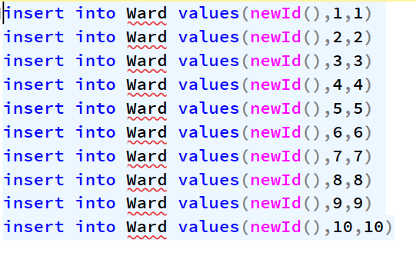

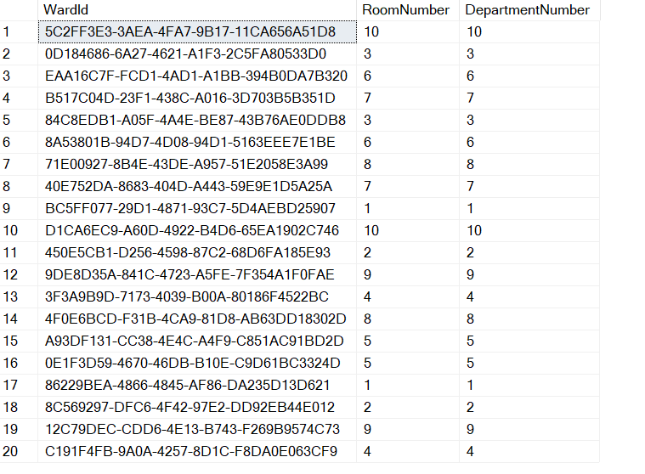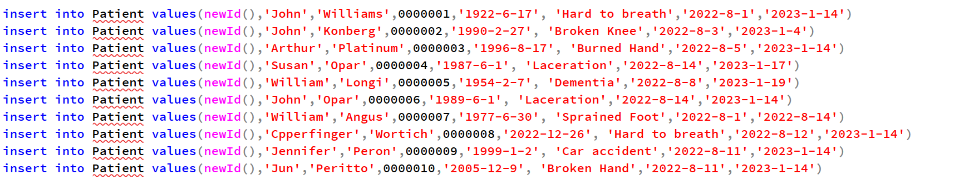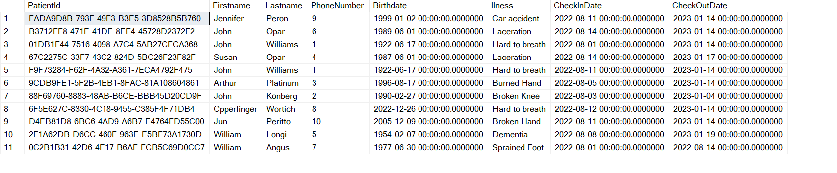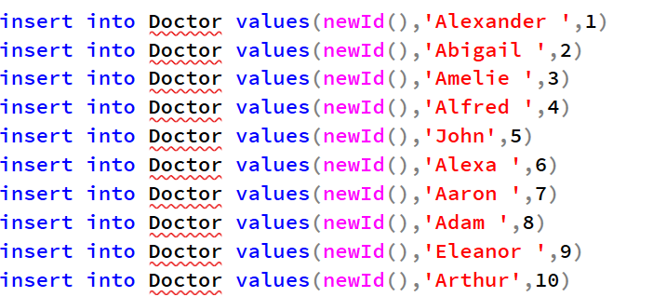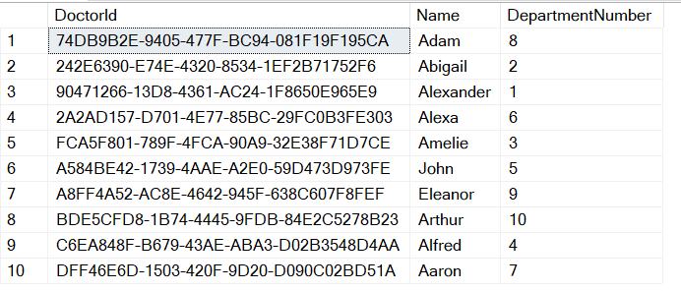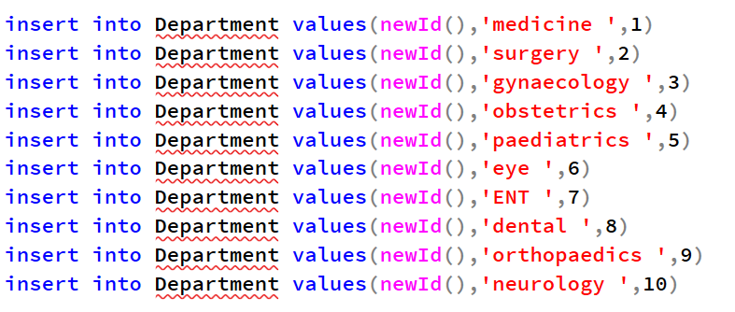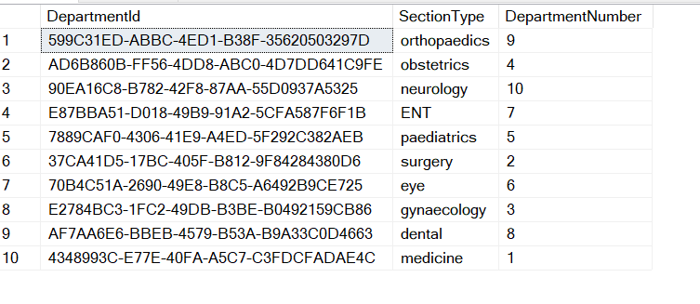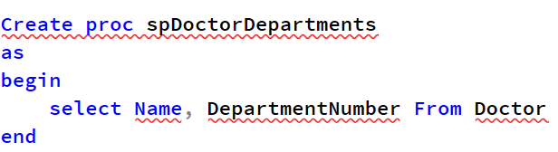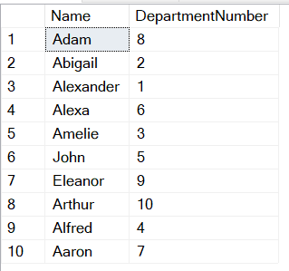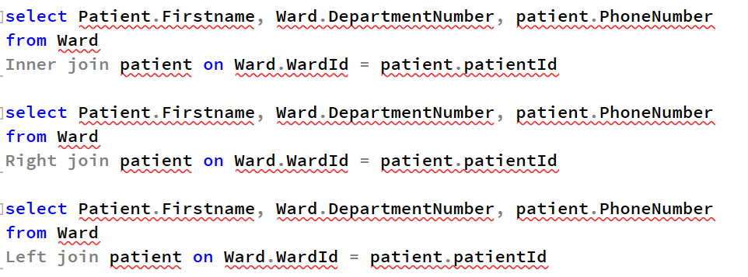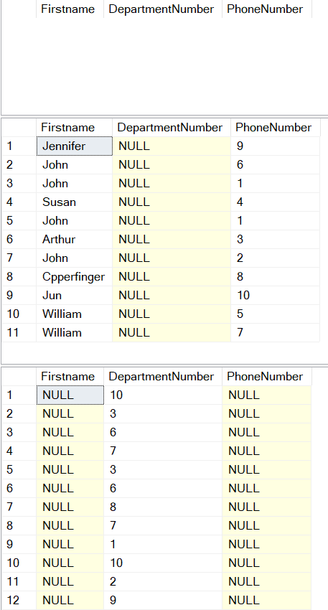

insert into Ward values(newId(),1,1)

insert into Ward values(newId(),2,2)

insert into Ward values(newId(),3,3)

insert into Ward values(newId(),4,4)

insert into Ward values(newId(),5,5)

insert into Ward values(newId(),6,6)

insert into Ward values(newId(),7,7)

insert into Ward values(newId(),8,8)

insert into Ward values(newId(),9,9)

insert into Ward values(newId(),10,10)

select * from Ward

insert into Patient values(newId(),'John','Williams',0000001,'1922-6-17', 'Hard to breath','2022-8-1','2023-1-14')

insert into Patient values(newId(),'John','Konberg',0000002,'1990-2-27', 'Broken Knee','2022-8-3','2023-1-4')

insert into Patient values(newId(),'Arthur','Platinum',0000003,'1996-8-17', 'Burned Hand','2022-8-5','2023-1-14')

insert into Patient values(newId(),'Susan','Opar',0000004,'1987-6-1', 'Laceration','2022-8-14','2023-1-17')

insert into Patient values(newId(),'William','Longi',0000005,'1954-2-7', 'Dementia','2022-8-8','2023-1-19')

insert into Patient values(newId(),'John','Opar',0000006,'1989-6-1', 'Laceration','2022-8-14','2023-1-14')

insert into Patient values(newId(),'William','Angus',0000007,'1977-6-30', 'Sprained Foot','2022-8-1','2022-8-14')

insert into Patient values(newId(),'Cpperfinger','Wortich',0000008,'2022-12-26', 'Hard to breath','2022-8-12','2023-1-14')

insert into Patient values(newId(),'Jennifer','Peron',0000009,'1999-1-2', 'Car accident','2022-8-11','2023-1-14')

insert into Patient values(newId(),'Jun','Peritto',0000010,'2005-12-9', 'Broken Hand','2022-8-11','2023-1-14')

select Patient.Firstname, Ward.DepartmentNumber, patient.PhoneNumber

from Ward

Inner join patient on Ward.WardId = patient.patientId

select Patient.Firstname, Ward.DepartmentNumber, patient.PhoneNumber

from Ward

Right join patient on Ward.WardId = patient.patientId

select Patient.Firstname, Ward.DepartmentNumber, patient.PhoneNumber

from Ward

Left join patient on Ward.WardId = patient.patientId

select * from Patient

insert into Doctor values(newId(),'Alexander ',1)

insert into Doctor values(newId(),'Abigail ',2)

insert into Doctor values(newId(),'Amelie ',3)

insert into Doctor values(newId(),'Alfred ',4)

insert into Doctor values(newId(),'John',5)

insert into Doctor values(newId(),'Alexa ',6)

insert into Doctor values(newId(),'Aaron ',7)

insert into Doctor values(newId(),'Adam ',8)

insert into Doctor values(newId(),'Eleanor ',9)

insert into Doctor values(newId(),'Arthur',10)

select * from Doctor

insert into Department values(newId(),'medicine ',1)

insert into Department values(newId(),'surgery ',2)

insert into Department values(newId(),'gynaecology ',3)

insert into Department values(newId(),'obstetrics ',4)

insert into Department values(newId(),'paediatrics ',5)

insert into Department values(newId(),'eye ',6)

insert into Department values(newId(),'ENT ',7)

insert into Department values(newId(),'dental ',8)

insert into Department values(newId(),'orthopaedics ',9)

insert into Department values(newId(),'neurology ',10)

select * from Department

Create proc spDoctorDepartments

as

begin

select Name, DepartmentNumber From Doctor

end

exec spDoctorDepartments